Wifi Hotspots Annecy

<https://www.mapcustomizer.com/map/Wifi%20hotspots%20annecy>

Machine generated alternative text:
CRAN-GEVRIER 
CARILLON 
'NOD 
A v Cran 
Chateau d'A 
LA BARALLAZ 
3. 
CHAVOIRE 
LA COMBE 
The bell tower 
Place Gabne 
Fauré, 74940 
Annecy, 
France 
21 Rue 
Sainte-Claire 
74000 
Annecy, 
France 
5 Quai des 
Vieilles 
Prisons, 
74000 
Annecy, 
France 
Alley of the 
Imperial, 
74000 
Annecy, 
France 
2 Avenue de 
Loverchy, 
74000 
21 st. 
Street 
Clair 
Casino Impérial 
cottee Of The 
Dukes 
The Imperial 
Palace 
2 Loverchy 
Avenue 
DI SOB 
LA PUYA 
49 6 
23 
necy @ 

Transport

Transport networks

**Road Network**

Distances by road between Annecy and...

... Paris : 545 km

... Lyon : 140 km

... Grenoble : 100 km

... Marseille : 420 km

... Geneva : 43 km

…Turin : 270 km

**Mont-Blanc Motorways and Tunnel (ATMB)**

Information, advice and traffic conditions in real time.

1 440, route de Cluses

74 138 Bonneville

**tel:** +33 4 50 25 20 00

**website**: [**www.atmb.net**](http://www.atmb.net/)

**Rail Network**

**SNCF**

Place de la Gare

74 000 Annecy

Information, booking : 36 35

Luggage, Lost property : +33 4 50 33 81 19

[**www.sncf.fr**](http://www.sncf.fr/)

**Air Network**

**Annecy Haute-Savoie Mont Blanc Airport**

8 route Côte Merle

74 370 Metz-Tessy

**tel:** +33 4 50 27 30 06

**fax:** +33 4 50 27 39 83

Flights to Paris, by Air France:

**tel:** +33 820 820 820

**website:** [**www.annecy.aeroport.fr**](http://www.annecy.aeroport.fr/)

**Public Transport**

**SIBRA**

(Annecy Region Bus Company)

66 chemin de la Prairie

BP 99

74003 Annecy Cedex

For all information on bus routes, timetables, lost property…and sale of bus tickets, a hostess is at your service from Monday to Friday from 7.30 a.m. to 7 p.m. and Saturday from 9 a.m. to 12 and 2 to 5 p.m.

**Espace SIBRA**

21 rue de la Gare

**tel**: +33 4 50 10 04 04

Several bus transport companies provide regular services to the big cities in the region (Lyon, Chambery, etc.); consult Yellow Pages.

**Taxis**

Booking Centre

**tel**: +33 4 50 45 05 67

From <<http://en.annecy.eu/576-transport-networks.htm>>

<https://www.sibra.fr/en/network-map>

Réseau de bus au 29.08.2011 
Communauté de Cagglomération d •Annecy 

<https://www.viamichelin.com/web/Traffic/Traffic_info-Annecy-74000-Haute_Savoie-France>

­­­La Bâlme- 
'dé-Sillingy 
Saint- 
Eusèbe 
Vo Ix 
ha eiry 
Sill 
.Nopglard 
HAU1r-SAVOl 
'«Poisy 
CZiv1e tz: 
Epag ! Tessy 
74000 Annecy, France 
Quintal 
kaïn t 41 
Sellevu 
d#nnecy 
évrier 
Saint- 
Nâves- 
Parmelan 
Monr 
Bann 
rier- 
Mont 
Baret 
Monr ne 
de 
Dingy- 
aint-Clair 
Houteville- 
üL-FierF• 
—ÀBoussy 
Lov,g3ny 
Chavanod 
Étercy 
arcell 
aint-Bernard 
le Pam 
Forét de 
La nfon 
Dents de 
Lanfon 
Pointe de 
lanf. 
Saint- 
Sylvestre 
ires- 

<http://en.annecy.eu/uploads/Image/44/WEB_CHEMIN_463_1172159885.gif>

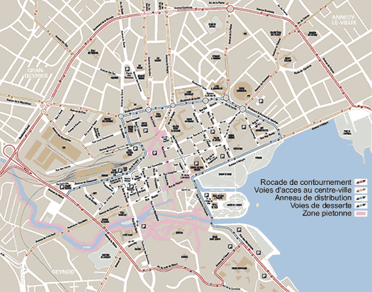

Screen clipping taken: 16/01/2018 09:55